October 2, 2012 · 11:58 am
↓ Jump to Comments

WWIII Will Begin With Sneak Attacks As Diplomacy Collapses Totally
Moore_NationalTime.jpg 1,000×1,249 pixels: photo from Detroit at the National Building Museum
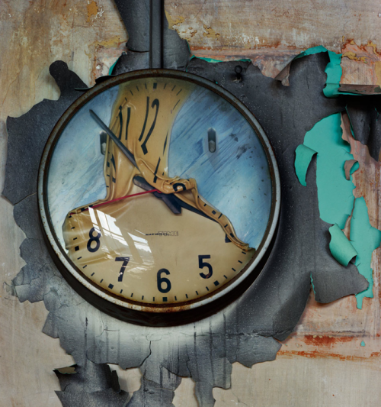
I had another one of my WWIII dreams last night. In it, I was at a conference where the tactics for future action were being debated. When it came for my turn to talk, everyone in the room began shouting and talking over me and I have a very loud voice but no one was listening. Everyone was eager to have a war because they thought they could have a decisive first strike moment and then everyone would surrender immediately to us. My explanations that this was insane and hopeless was totally ignored. I woke up as the first nuclear warheads were launched.

Once upon a time, over 40 years ago, I was a participant in a very serious debate held at Princeton University, we all sat at this oblong table in a lecture hall and William Safire lead the pro-sneak attack war side and I was virtually alone in the peaceful co-existence side. This arrangement using a NYT editorialist who was (obviously) a Zionist against a woman (myself) who had a record of accurate predictions of the future (which the CIA was very aware of due to my dad being CIA) was supposed to lead to a victory in the argument for the Nuclear Defense Shield.

In this argument which grew very heated, I forced Safire to admit the only reason he and the other neocons were pushing for this defense shield was so they could attack with impunity and no one could stop us from being aggressively violent. ’Once we have this shield up, Russia will have to surrender to us without anyone firing a shot!’ he claimed triumphantly. I said to him, ‘Russia and China are watching this debate and will take preemptive measures and strike before it is installed.’ Indeed, Reagan had his advisors there and they applauded Safire while Russian and Chinese observers told me that they applauded my responses as correct.

Reagan embraced the Nuclear Defense Shield and an enraged Russia and China both became openly hostile due to this. Guess what? Eventually, Reagan embraced MY arguments and he negotiated a defense stand back treaty himself with Gorbachev in Iceland. This enraged the pro-nuclear war gang greatly. To this day, the neocons in the GOP hail Reagan as a great warrior hero and not as the man who finally saw my point and followed my suggestions for a diplomatic retreat from warfare.

The news isn’t good, it is all about causing WWIII. The US has been working insidiously to surround both Russia and China with our defense set-ups which are designed to neutralize both, supposedly, while allowing us to disarm everyone else on earth (Iran, for example) while increasing our nuclear arsenal and sending it all around the planet with sneaky subs. Submarine warfare is by definition, all about being sneaky and showing no mercy. From day one, it was used mainly to destroy and murder unlike previous naval warfare where civilian ships would be seized and boarded by either governments or pirates.

Some of my readers have fallen for a false history here thinking it is OK to sink civilian ships and kill everyone. Before WWI, neutral countries would complain if anyone barricading trade during war, seized their ships. But before WWI, the passengers for the most part where kept alive especially civilians.

Germany broke this rule and everyone was outraged by this but by WWII, everyone embraced the principle set by the Germans that killing everyone at sea on neutral ships was strategically wise. This was insane and dangerous. Israel, just this last year, invaded a civilian ship with no real weapons of any sort, on the high seas and murdered neutral citizens in order to scare off peace protesters trying to break the noxious Israeli blockade of Gaza. The US allowed its own citizens to be murdered on the high seas as we allowed this previously when the USS Liberty was openly repeatedly attacked by Jews hoping to drag us into a war on their side by lying about who attacked the ship. To do this, they had to kill everyone but enough survived to scotch this grand scheme.

This is also true, the principle of doing sneak attacks on civilians was expanded in WWII by again, the Germans, by using air machines to bombard entire cities without warning in Spain. At first, the US and England and France were outraged by this. By the end of WWII, everyone was doing this. The final sneak attack was the US flying just one plane which the Japanese thought was a spotter plane, over Hiroshima and with zero warning, dropped a secretly developed nuclear bomb on civilians killing untold numbers of women, children, the elderly and animals, trees and everything in sight.

The temptation to do a first strike nuclear attack is extremely high which is why close, careful diplomacy and a hesitation of using undiplomatic, cowardly ways should be avoided. When the US claimed at the UN that Saddam had WMD it was imperative to find these after the invasion and nothing was found. The US, instead of arresting Bush, Cheney and Powell and trying them for a war crime, reelected this gang. We collectively stuck out our lower lips and announced, we didn’t care if the invasion was totally illegal, instead, we upped the ante and submitted to the UN a long list of countries we wished to bomb into submission.

The US is the aggressor nation now. We form secret treaties with former war criminal nations like Japan opening the door for aggression against China, Russia and both Koreas even though one of the Koreas is our ‘ally’. Let’s look at today’s news to see how this all plays out: North Korea: Spark Could Set Off Nuclear War, the US cannot build up military forces in Asia and have secret nuclear armed subs sneaking about right offshore of many nations, backing up Japan’s territorial claims against everyone.

China: That Empty Feeling is a Safire-like editorial claiming that China is a paper dragon (!!!!!) easily defeated without barely firing a shot (after our sneak attacks succeed, of course).

After secret diplomatic talks with China, the Philippines announced it would not send more troops to the disputed Spratly Islands. There are already a hundred Filipino marines based in the Spratly Islands and it’s unclear what the Chinese said to prevent more troops from being sent.

There is growing evidence that corruption and unreliable economic data is causing growing financial problems in China. There has been massive overbuilding, which has been impossible to hide. All those unoccupied residences and commercial buildings are very obvious. These were all built with loans from state-owned Chinese banks. The government refuses to reveal how badly the banking system has been hurt by all the obvious (and less obvious) bad loans. There is a lot of corruption in China and several provinces and one major city (Dongguan) are talking about bankruptcy because they cannot borrow enough money to keep their unprofitable operations going.

Grossly misunderstanding what is going on in China is a rampant problem with most analysis in the US today. China doesn’t care if internal deals fail. They owe money to no outsiders. The US, on the other hand, owes money to everyone in Asia, big time. Our own banking system is destroying itself trying to support the eternal income growth of billionaires who are already far too rich. Chinese peasants are moving up the income scale while US workers are declining rapidly due to dropping wages and raging inflation in food, fuel, education and medicines.

China is not involved at all in an ideological religious war with a billion Muslims all over the planet earth. This insane war is hard to control and is fought everywhere with sneak attacks, assassinations and terrorism on all sides happening at various times, more and more frequently. And unlike China, the US has many mentally ill people plotting to murder numbers of victims before either committing suicide or turning themselves in. On top of this is the loss of control of entire cities where industries moved to China leaving workers here to form gangs and go around, like in Mexico, drug dealing and killing people including the police.

Haruki Murakami criticises ‘hysteria’ over islands row: Japanese novelist calls on everyone to step back from the brink of war. China just banned the sale of any Japanese materials this week and this is quite popular in China. The average Chinese doesn’t need the government reminding them of how hideously the Japanese tormented them during WWII. Everyone has stories of Japanese criminal actions. And they will not forget this, either. Japanese business is collapsing in China, the world’s future #1 market. It is #2 to the US and has already overtaken the US in auto sales, for example.

Noda revamps Cabinet, giving posts to outspoken Maehara, Tanaka－ 毎日ｊｐ(毎日新聞): As I have pointed out, a desperate Japan has decided that war is the solution to pressing problems caused by the popping of the real estate/banking bubble and the destruction caused by the earthquake and Fukushima disaster:

As some recent opinion polls show that the ruling Democratic Party of Japan is at risk of defeat in the election, which must be held within a year, Noda hopes the strong speaking skills of Maehara and Tanaka, who used to enjoy great public popularity for her sharp tongue, could help buoy the government…But one of Noda’s aides said the appointment of Tanaka is a “gamble” given that she was once sacked as foreign minister in 2002 by then Prime Minister Junichiro Koizumi for reportedly having caused confusion within the ministry.

There is also some concern that the hawkish security stance of Maehara, who has been popular with the public partly due to his youthful image, could further irritate China and South Korea as relations between Japan and its two neighbors have been frayed over territorial disputes.

Far from negotiating with China, Japan has simply become even more belligerent. I propose this is due to Hillary Clinton, a novice when it comes to mega-politics due to little historical understanding, stupidly gave Tokyo the greenlight to defy China and Russia and push claims to their heart’s content. Like Austria did to Germany at the start of WWI, they use these secret assurances to launch a war they cannot possibly win in ANY scenario.

It gets much, much worse: 82% rap lukewarm response to anti-Japan protests in China over Senkakus: Mainichi poll－ 毎日ｊｐ(毎日新聞)

In the poll, 63 percent expressed their support for Japan’s nationalization of the islands, down from 73 percent in the previous poll on Sept. 15 and 16. Twenty-five percent disapproved of nationalization, against 22 percent in the earlier poll.

As for the deployment of MV-22 Osprey aircraft to the U.S. Marine Corps Air Station Futenma in Okinawa Prefecture, respondents to the Mainichi survey were equally divided, with 46 percent in favor because the deployment will be beneficial to Japan’s security, and 45 percent against the measure.

The Japanese public has been trained for years and years in denial of war crimes. Like the US, they think that sneak attacks and launching imperialist wars is a great idea if only one can be powerful enough to succeed. Support of the government claims on islands has been dropping as more and more Japanese remember what happened during WWII, at least, to THEM. Unable to grasp why the Chinese could suddenly hate them so much, clueless as to why the Chinese are angry, they hesitate only because they fear death, themselves.

As they should! There is a 100% chance that all of Japan would be a smoking ruins identical to Fukushima if they choose to go to war. Almost no one will survive. Guaranteed. Right now, China is retaliating Japanese-style. The Japanese have done this for years and years to the US while we protect that country: Japanese firms braced for China slowdown amid lengthier customs checks – AJW by The Asahi Shimbun
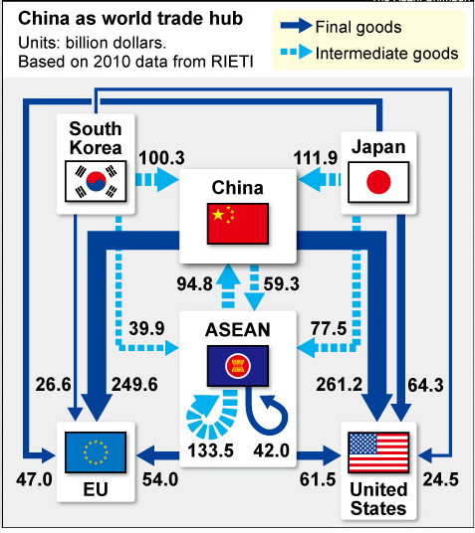
Japan, Taiwan and South Korea all pour trade into China by sending in parts to be assembled which China exports to the EU and US. Then both the EU and US blame China for this. The Chinese patiently let this happen because they were building up China this way. But the US was stupid to let the other allies do this to us but then our own rulers, leaders and elites joined in to do this too, manufacturing in China and then whining about the loss of US jobs and blaming China, not themselves, for this. Romney says his ‘heart aches’ for jobless. He, himself, removed our jobs to China and didn’t give a damn who he hurt in the US.

Three US Troops, 11 Others Killed in Afghan Suicide Bombing : The Pentagon is hopping mad at the successful Taliban tactic of infiltration and attack. The US is trying to rule Afghanistan and failing miserably. And this is too expensive, too, so of course, we are doubling down and doing this more and more. Two Americans killed in unusual gunfight involving several Afghan soldiers – The Washington Post: the Post is a warmongering rag. They cannot believe that primitive peasants can figure out these clever schemes for fighting the world’s most heavily armed empire. Talk about never understanding history!

US investors pulled $300B out of equity markets in last two years putting money into bonds. This is typical of times leading to wars. Zero interest loans to European and US banks leads to governments using this to arm their troops. And this leads to war. Zirp internal lending also causes inflation and the only cure for that is war whereby the government can then enforce rationing. If there is rationing, holding gold so one can buy stuff becomes meaningless. Just trust me on that. History is quite clear on this matter.

